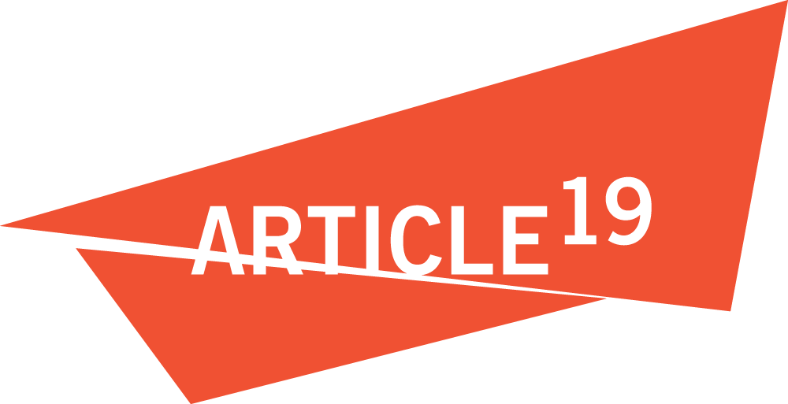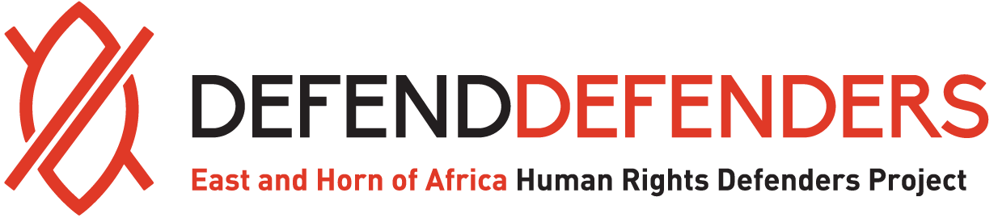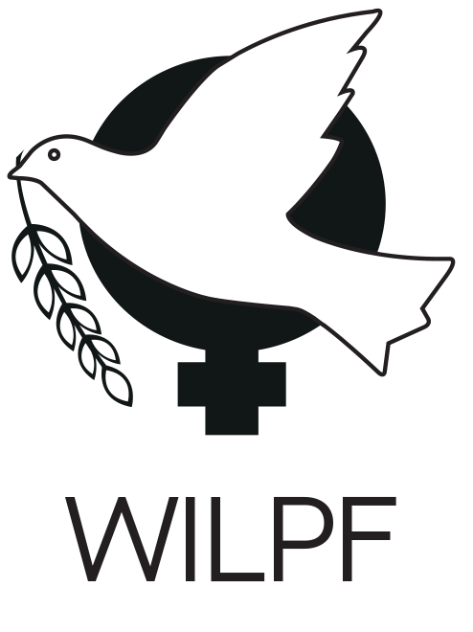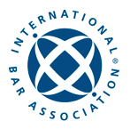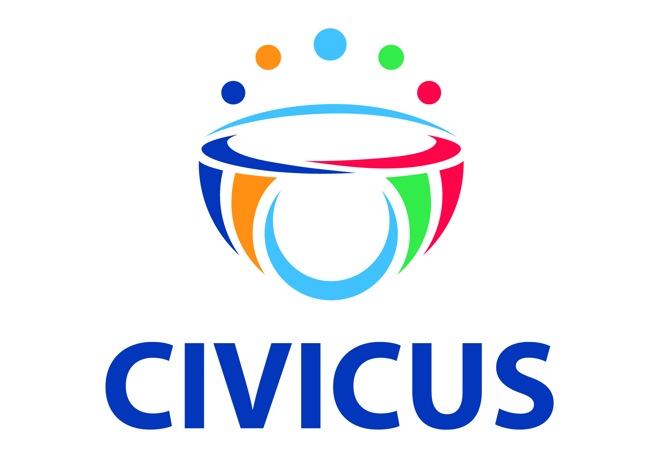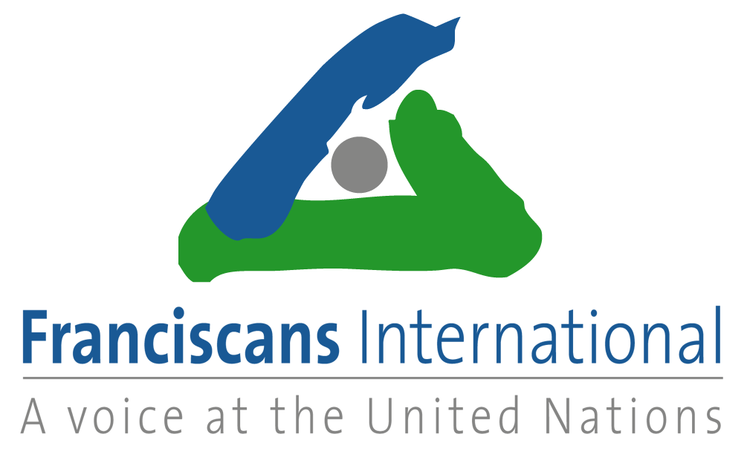****



****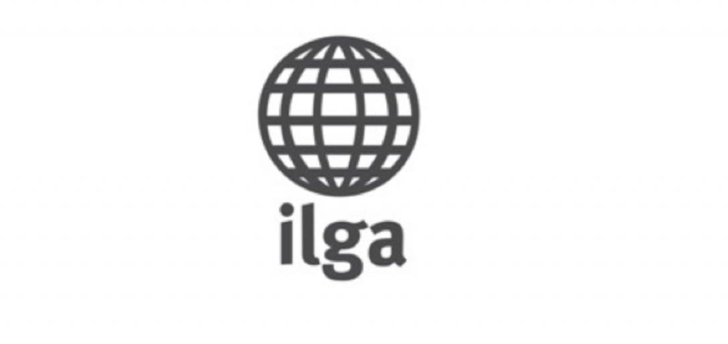****

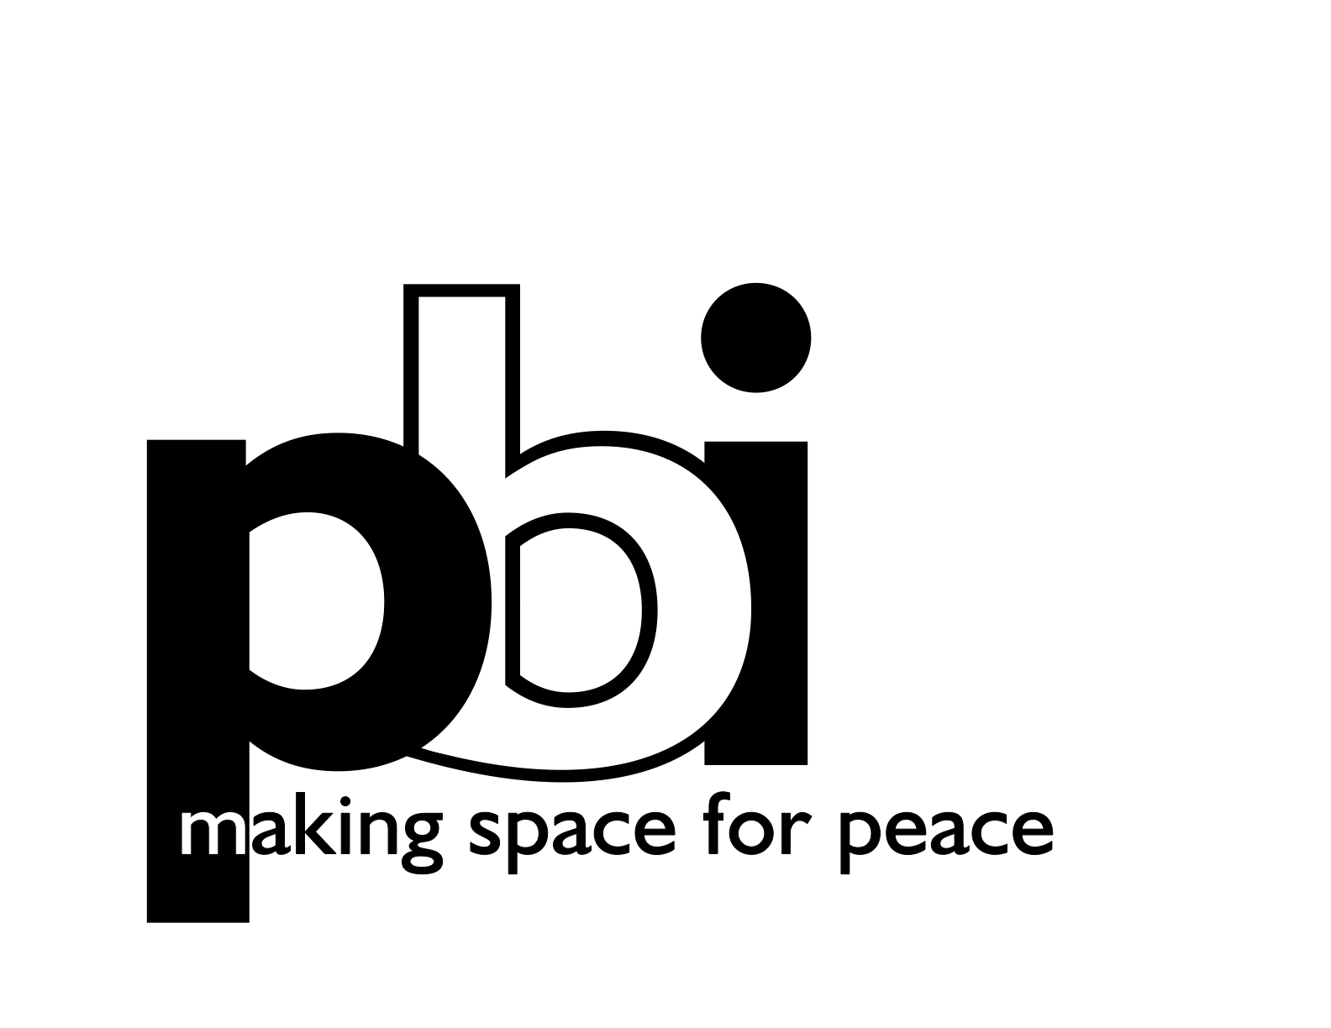

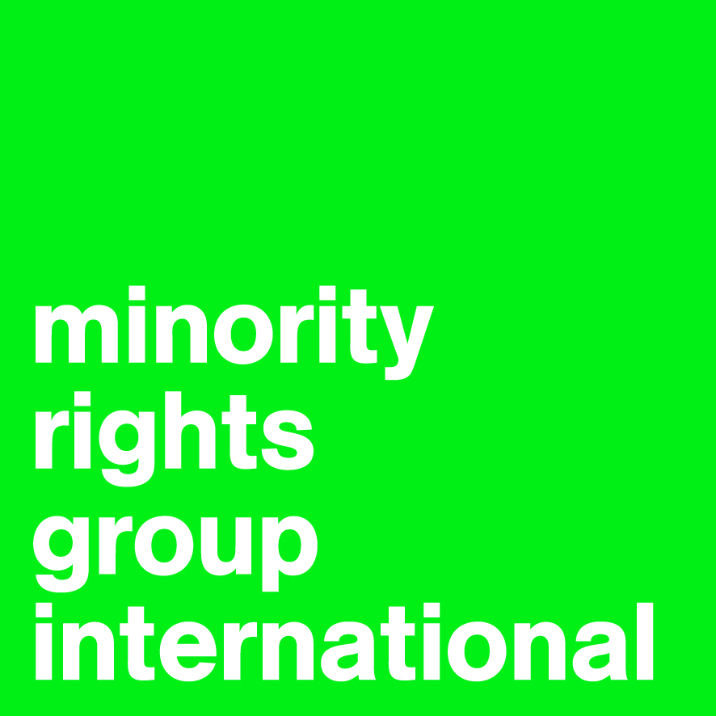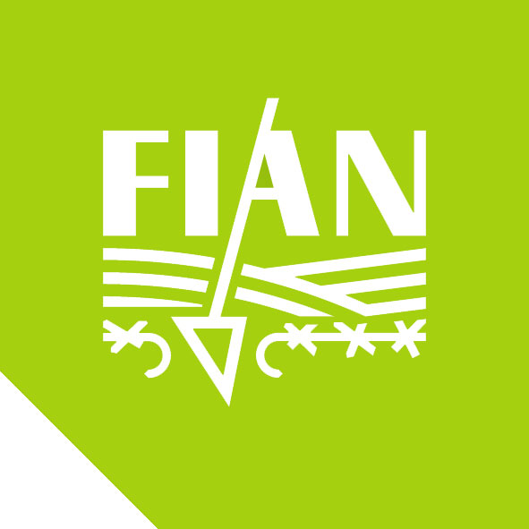



**United Nations Human Rights Council**

**35th Regular Session,**

**6 to 23 June 2017**

**Agenda Item 3**

**Joint Oral Statement of Article 19, Asian Forum for Human Rights and Development (Forum-Asia), Bahá'í International Community, CIVICUS - World Alliance for Citizen Participation, DefendDefenders (the East and Horn of Africa Human Rights Defenders Project), FIAN International, Franciscans International, the International Bar Association, the International Commission of Jurists (ICJ), International Federation for Human Rights Leagues (FIDH), International Lesbian and Gay Association (ILGA), the International Movement against All forms of Discrimination and Racism (IMADR), International Platform Against Impunity, International Service for Human Rights (ISHR), Minority Rights Group International, Peace Brigades International (PBI), Universal Rights Group (URG), and Women’s International League for Peace and Freedom (WILPF), in General Debate on item 3**

**CIVIL SOCIETY SPACE AND THE HUMAN RIGHTS COUNCIL**

13 June 2017

Mr President,

This is a joint statement on behalf of a number of NGOs.

We thank States for their commitment to address the shrinking space for civil society.

We draw the Council's attention to the fact that since 2013, the number of desks reserved for NGOs in room XX for Human Rights Council sessions has been reduced from 24 to 2, leaving only the two speaking seats we are now sitting in.

This has been drawn to the attention of successive Presidents of the Council but the space has continued to shrink.

We invite all delegations to reflect on the impression this gives to civil society, not to mention States and other international actors, about the Council's commitment to addressing shrinking civil society space.

I thank you Mr President.

Statement delivered by:

Matthew Pollard, International Commission of Jurists

([un@icj.org](mailto:un@icj.org), +41 79 246 54 75)