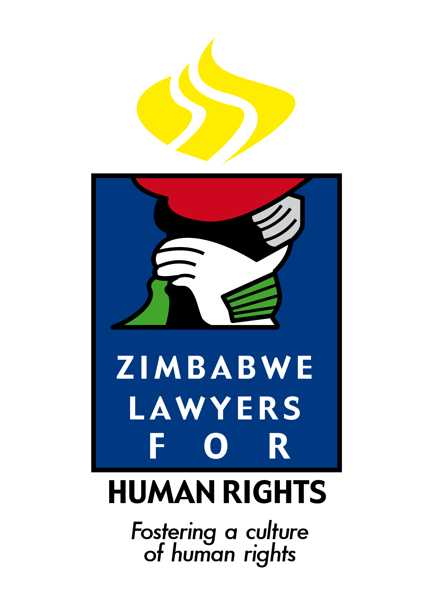

31 October 2025 (For immediate release)

Southern African Human Rights Defenders Condemn Escalating Human Rights Violations Following Tanzania’s 29 October 2025 Elections

We, the undersigned human rights organisations operating in Southern Africa, and members of the Southern Africa Human Rights Defenders Network (Southern Defenders), are deeply concerned about the escalating human rights crisis in Tanzania following the 29 October 2025 elections. We strongly condemn the ongoing electoral violence and the growing reports of intimidation, harassment, and human rights violations in Tanzania.

We note with grave concern the failure by the Government of the Republic of Tanzania to guarantee the fundamental rights and freedoms of its citizens, including the right to life, security of person, and freedoms of expression, association, and political participation as enshrined in the Constitution of the United Republic of Tanzania, the Southern Africa Development Community (SADC) Treaty and its relevant protocols, the African Charter on Human and Peoples’ Rights (ACHPR), and the International Covenant on Civil and Political Rights (ICCPR), to which Tanzania is a State Party.
In the period leading up to the elections, national human rights groups documented a sharp increase in serious human rights violations, including torture, abductions, enforced disappearances, and arbitrary arrests. These violations predominantly targeted opposition leaders and members, journalists, and human rights defenders (HRDs). The main opposition party, CHADEMA, objected to the holding of elections without necessary reforms. Consequently, its leader, Tundu Lissu, was arrested and has been in detention since April 2025 on trumped-up charges of treason.
National human rights groups have also reported that, between 1 and 25 October 2025 alone, Tanzania experienced an alarming wave of 52 abductions across various regions, mostly affecting CHADEMA members and supporters, including teachers, pharmacists, motorcyclists, and other civilians. Of particular concern is the enforced disappearance of former Tanzanian ambassador to Cuba, Humphrey Polepole, a high-profile case that remains unresolved.

Further to this, Southern Defenders notes that the 29 October elections fell far short of both national and international standards required to ensure free, fair, and credible polls. Regrettably, credible observer missions, including those from SADC and the European Union, were denied accreditation. The few observers permitted to operate did so under conditions of fear and intimidation. Media freedom was severely curtailed, with widespread censorship and an internet shutdown that created an information blackout. The democratic space was further restricted through harassment of journalists and civil society actors. HRDs continue to face reprisals for condemning electoral violence and calling for transparency.

On election day, Southern Defenders received credible reports of a heavy military presence in major towns across the country. Citizens took to the streets to protest, demanding electoral reforms and calling for a boycott of the polls. The state’s response was violent and disproportionate. Rights groups estimated that at least 200 people were killed as a result of clashes and excessive use of force by security agencies. By 31 October 2025, media reports indicated the number of casualties to be about 700. The deployment of security forces and the suppression of peaceful dissent have created an atmosphere of fear and mistrust, eroding public confidence in democratic governance and threatening long-term peace and stability.
Instead, the use of excessive force by security agencies, restrictions on opposition activities, and the suppression of independent media and civil society voices have created an atmosphere of fear and mistrust. Such actions undermine the integrity of the electoral process, erode public confidence in democratic governance and are a threat to peace and stability.
Tanzania has long been regarded as a pillar of peace and stability in the Southern African region. Southern Defenders reminds the government of the Republic of Tanzania that it bears the primary responsibility to uphold democratic practices and protect all citizens, regardless of their political affiliation or opinion. Therefore, we urge the Tanzanian government to safeguard this legacy by recommitting to constitutionalism, the rule of law, and respect for human rights and fundamental freedoms.
Southern Defenders also expresses deep concern over the deportation of Dr. Blessing Vava, who was detained and interrogated for several hours upon arrival at Julius Nyerere International Airport. His passport was confiscated. Dr. Vava’s intended mission to engage with civil society counterparts was a legitimate effort to promote solidarity and collaboration with those who fight for justice and equality. His treatment by authorities reflects Tanzania’s growing intolerance towards civil society and HRDs.

Southern Defenders remain deeply troubled by the shrinking civic space and increasing hostility towards human rights defenders, civil society activists, and opposition voices in Tanzania. These actors play a crucial role in promoting transparency, accountability, and justice values essential for sustainable peace and democratic governance.

As a member of SADC and the African Union, Tanzania is bound by the SADC Treaty and Protocols, as well as the African Charter on Democracy, Elections, and Governance, which obligate State Parties to promote democratic governance and prevent violence or intimidation during electoral processes. It is therefore crucial for Tanzania to recommit to these principles and work towards resolving conflicts in a manner that aligns with democratic ideals.

Southern Defenders, therefore, calls upon the Government of Tanzania to:

(a) Lead by example to Champion alignment with the SADC Treaty & Declaration, including all Protocols, particularly the SADC Principles Guidelines Governing Democratic Elections, SADC Protocol on Politics, Defence Security Cooperation, as the outgoing Chairperson of the Organ on Politics, Defence and Security Cooperation to safeguard the people of this region from breakdown of the rule of law, reprisals, intimidation, and aggression.

(b) End reprisals targeting human rights defenders, civil society activists, including repealing aggressive laws conflicting with AU Agenda 2063, and Article 10 & 11 of the African Charter on Human and People’s Rights, Guidelines on Freedom of Association and Assembly safeguarding freedom of association, assembly, expression.

(c) Implement the AU Charter on Democracy, Elections, and Governance provisions safeguarding peace, security, democracy, rule of law, transparency and accountability to prevent violence, deportation of election observers, and human rights defenders, civil society cooperating with the UN and AU human rights systems

(d) Cease all forms of violence, intimidation, and harassment against citizens, journalists, opposition members, and human rights defenders.

(e)Release all political prisoners, including Tundu Lissu, and account for all victims of abductions and enforced disappearances.

(f) Ensure independent investigations into reports of killings, abductions, and other human rights violations, with perpetrators held accountable.

(g)Restore civic and media freedoms and guarantee the safety of human rights defenders.

(h)Recommit to regional and international human rights obligations, upholding democratic principles in accordance with the SADC and AU frameworks.

Signed

- International Commission for Jurists (ICJ)

- Human Rights Institute of Southern Africa (HURISA)

- KUTEKESA: Movemento de Defensores de Direitos Humanos

- Zimbabwe Lawyers for Human Rights (ZLHR)

